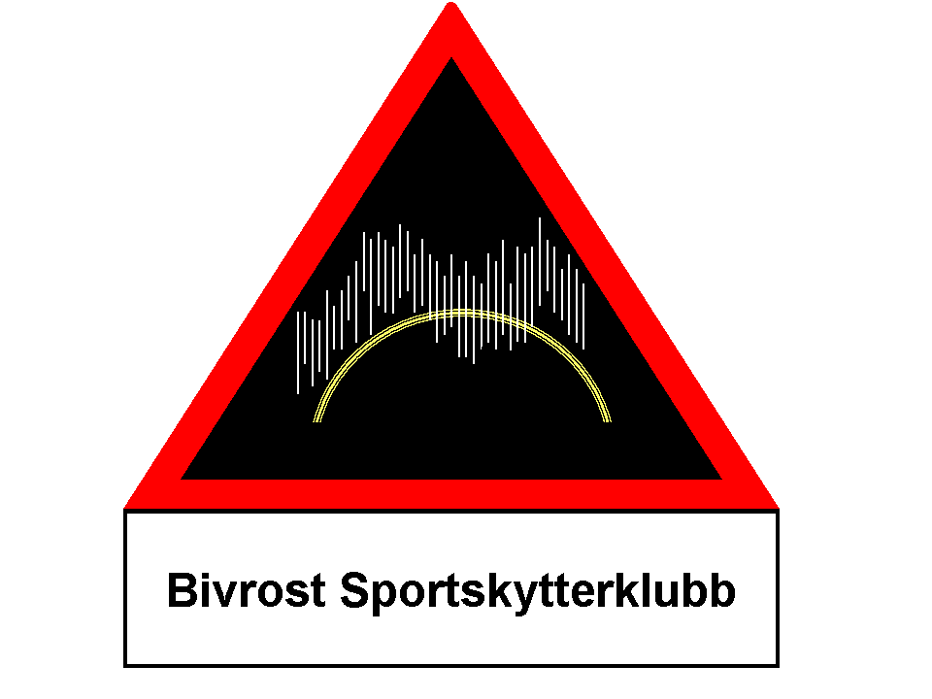
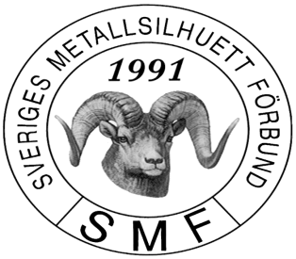

Nordic Championship
Big bore and Small bore rifle
2016

BSSK, in cooperation with SMF and NMF, invites to Nordic Championship
Small bore and Big bore rifle 2016 in Fredriksberg Sweden

DATE: Friday 23.09.2016 - Sunday 25.06.2015
PLACE: Säfsens shooting range, Fredriksberg (along road 64 aprox 300m north of exit
to Fredriksberg - road 245)
ENTRIES: Per e-mail/phone to the Match Director (see below) no later than 21.09.2016.
PRACTICE: Friday 23.09.2016 as time permits.
NUMBER OF ENTRIES: Each shooter may enter all events if the time permits.
START TIME: Friday after appointment, Saturday 9:00-18:00, Sunday 9:00-13:00
Shoot-offs on Sunday 25.06.2016 start as soon as ready
AWARD CEREMONY: After shoot-offs, Sunday 25.09.2016
ENTRY FEES: SEK 200,- per.event
No fees for aggregate
SEK 300,- for each team
All fees are paid at the range before first entry.
CATEGORIES: SMALL BORE BIG BORE
Light Hunter
Silhouette Silhouette
Fri Fri (National Norwegian event)
Junior (with soft support for rifle)
2 gun aggregate 2 gun aggregate

TEAM
3 shooters teams in Small Bore and Big Bore.
NUMBER OF SHOTS: 40 + 5 sighting in shots. Shoot off will be 5 shots first round, then 5 shots.
GUN CHECK: If necessary.
FOOD: Not available at the range.

LODGING: Säfsens stugby: 0591-775000, Säfsens vandrarhem: 0591-205 65
www.safsen.se www.safsenlogi.se
AWARDS: NMF medals to the three first places in each event.
1st-3rd in each class (INT, MAS, A, B) will be awarded diploma.
RESULTS: Will be sent by mail to the contact person for each country, or directly to the shooters that provide the organizers with their e-mail address.
GENERAL: IMSSU rules apply for the international events. National rules apply for national events.
OTHER: Shooters/spotters must help with setting targets.
Bring your own ground sheet if you need one.
All silhouette shooters are welcome to participate.
Only Nordic shooters can be Nordic Champions
MATCH DIRECTORS: Nikolay Mustaparta: president@metallsilhuett.no

ALL METALLIC SILHOUETTE SHOOTERS ARE VERY WELCOME!

